Results

To identify the bacterial composition of the microcosm starting materials, we characterized the microbial communities in samples of the alfalfa soil as well as the alfalfa and compost amendments using amplicon sequencing of the 16S rRNA gene. We compared the most abundant phyla in the amendments and soil (Figure 1). Overall, the five most abundant phyla from each amendment and soil represent comprise the majority, at least 75%, of the total bacterial community in each sample from the soil and amendments. The five most abundant phyla in the alfalfa amendment were unclassified bacteria (sharing no homology to a known reference gene), Proteobacteria, Bacteroidetes, Actinobacteria, and Firmicutes with relative abundances of 47%, 40%, 7%, 5%, and 1%, respectively. The starting soil had abundances of Proteobacteria, Actinobacteria, Acidobacteria, unclassified bacteria, and Verrucomicrobia at 22%, 20%, 17%, 13%, and 10%, respectively. Composition of the compost amendment includes the phyla Actinobacteria, unclassified bacteria, Firmicutes, Proteobacteria, Chloroflexi with abundances of 33%, 26%, 25%, 7%, and 4%, respectively. Based on the overall community composition, we estimated the Bray-Curtis distance between soil, compost, and alfalfa, and found these to be significantly different (PERMANOVA, P < 0.001).

The chemical characteristics of the microcosm inputs and starting soil also varied in inorganic N concentration and C:N ratio; inorganic N concentration of the starting soil was 3.34 ppm while the concentration in the alfalfa and compost amendments was 25.53 and 13.91 ppm, respectively (Table 1). In regards to C:N ratio, the starting soil was measured at 12.56 while alfalfa and compost inputs were 20.18 and 28.97, respectively (Table 1).

Four experimental treatments were characterized in alfalfa soils and included amendments with alfalfa, compost, or a mix as well as a no amendment treatment (hereafter called reference soils) over 97 days. Following the incorporation of amendments with soil, levels of inorganic N increased in both the alfalfa-amended and mix-amended microcosms from day 7 to 97 of the incubation. Similarly, this trend towards inorganic N increase occurred in reference soils. In contrast, the level of inorganic N decreased in the compost amended microcosms from day 7 to 49 before increasing slightly by day 97 (Figure 2). Alfalfa amended soils had significantly higher inorganic N concentrations on days 14 to 97 than other treatments, and by day 97 had 2-fold greater inorganic N compared to reference soils. Mix-amended soils initially were observed with lower concentrations of inorganic N compared to reference but increased to levels comparable to reference soils by day 97. Compost amendments resulted in a significantly lower concentration of inorganic N on all days of the incubation compared to the reference soil and had inorganic N concentrations less than one ppm on days 21, 35, and 45 (Figure 3).

All amended microcosms yielded significantly higher MBC levels than unamended soils. Alfalfa amendments had the most significant positive difference, with a two to three-fold higher MBC than reference and achieving the most MBC within the experiment, 780 mg MBC C/kg dry wt. soil on day 14. Reference soils also nearly doubled in microbial biomass on day 21 before declining to baseline concentrations on day 97. By day 35, amended microcosms had similar MBC and maintained this relationship throughout the experiment, while remaining significantly higher than reference MBC levels (Figure 4).

The bacterial community composition of the incubated microcosms was significantly different between treatments and over time. NMDS ordination for each sample revealed significantly different clustering of samples from reference soils without amendment, soils with compost, soils with alfalfa, and soils with a mixture of alfalfa and compost (Figure 5). Non-parametric multivariate analysis of variance (NPMANOVA) shows significant effects from both time (R2 = 0.34) and treatment (R2 = 0.16) (Adonis, P < 0.001, Table 2) in explaining the variation between samples.

To understand what microbial populations could be originating from amendments and potentially colonizing alfalfa soils, we identified amendment-specific OTUs in the incubated mesocosm samples that were not detectable in original soils or incubated reference microcosms. In total, 67, 307, and 386 amendment-specific OTUs were identified from alfalfa, compost, and mix amendments, respectively. Compared to the total number of observed OTUs in amended mesocosms, these amendment-specific OTUs comprised a very small fraction, ranging from 0.46 to 1.14% (Table 3).

To better understand the influence of the measured and calculated environmental variables of inorganic N, total C, and N, C:N ratio, microbial biomass C, pH and gravimetric water content on the microbial community, in addition to treatment and time, distance-based redundancy analysis was performed on the weighted unifrac distance matrix (Figure 6). Further, variable selection via stepwise ordination was evaluated to identify which of the environmental variables significantly contributed to the variation observed. Results from variable selection indicated that day, treatment, nitrate concentration, C:N ratio and TOC were significantly contributing to the variation observed. These variables contributed to a total of 50.35 % of the variation, while the remaining environmental variables explain only .21 % of the variation and are not significantly contributors (Table 4).

To better understand the impacts of time on the mesocosms, hierarchical clustering of samples, based on Bray-Curtis dissimilarity within each treatment, was used to identify groups of samples with similar responses over time. For all amendments, we observed two distinct groups of microbial communities. These groups were described as “early” for samples from days 7, 14, and 21 and “late” for samples from days 35, 49, and 97 (Figure 7-10). Within both early and late samples, we next identified specific OTUs that were significantly abundant (> 2 log fold change in abundance) in amended treatments relative to reference soils (Figure 11-16). ~~OTUs with an LFC > 4 are in each group are considered “super responders”, their presence in early and late groups combined with a high LFC lead to this designation (Table 5-7).~~  Roughly half (X%) of the amendment-specific enriched OTUs are associated with Proteobacteria, while the remaining are unclassified or associated with the Bacteroidetes, Planctomycetes, Actinobacteria, Firmicutes, and Chloroflexi. The most abundant amendment-specific OTUs were detected in compost amendments and were specifically associated with the phyla Chloroflexi.

The phylogenetic association of the most enriched amendment-specific OTUs sequences in early and late samples were identified (Figure 17). In general, we observed patterns in the phylogenetic relationship between these OTUs. For example, Node 158 contains 10 OTUs most similar to known Proteobacteria and are only observed in compost-amended early and late samples. Three OTUs most similar to the *Cellvibrio* were detected only in early compost samples, with the exception of except for Otu00329 which was also responding in the early alfalfa microcosms, node 126.  OTUs associated with *Pseudomonas spp.*were identified in alfalfa-amended samples and early mix-amended samples. Node 232 represents 5 OTUs associated with the phyla Bacteroidetes that are mostly associated with the early response groups for all alfalfa and mix groups. Several OTUs closely related to Chloroflexi *Sphaerobacter, n*ode 183, are present in early compost, except for Out00022, which was responding to early and late mix and compost. Node 201 contains five Otus from the phyla Planctomycetes, each of which was only responding during the late samples from each treatment. The exception being Otu00847, which was responding to the amendments in each response group of each treatment. Verrucomicrobia, node 212, are present as responders in the early alfalfa samples and swell as the early mix samples for Otu01345 Verrucomicrobia *Verrucomicrobium.*Node 186 represents eight OTUs from the phyla Firmicutes, which are generally associated with alfalfa samples. Five OTUs represent Actinobacteria as responders, related to the genera *Thermobifida, Cellulomonas,*and *Glycomcys*as well as two unclassified sequences, generally associated with compost addition, node 193. Node 132 contains several OTUs from the phyla Proteobacteria and closely related to OTUs from the genera *Haliea.*

 Six responding OTUs originated from the amendments, and each of these “alien” OTUs responded only in the early treatment groups associated with the amendment from which they originated. Three OTUs from the compost amendment detected as responding are part of node 183. Interestingly, the “alien” compost OTUs did not persist into the late group, while the native but closely related *Sphaerobacter*was present in all compost and mix response groups. The “aliens” detected from the alfalfa amendment were distributed across the phyla Proteobacteria, and are associated with Gammaproteobacteria and Alphaproteobacteria (Figure 17).  Finally, we evaluated the relative abundance of amendment-specific significantly enriched OTUs in the total microbial community over time (Figure 20-25), identifying that largely these OTUs comprise a very small fraction (range 1-7%) of the total population.

Figure 1 Relative abundance of top five phyla in each input.

Figure 2 Inorganic N dynamics in incubated microcosms.

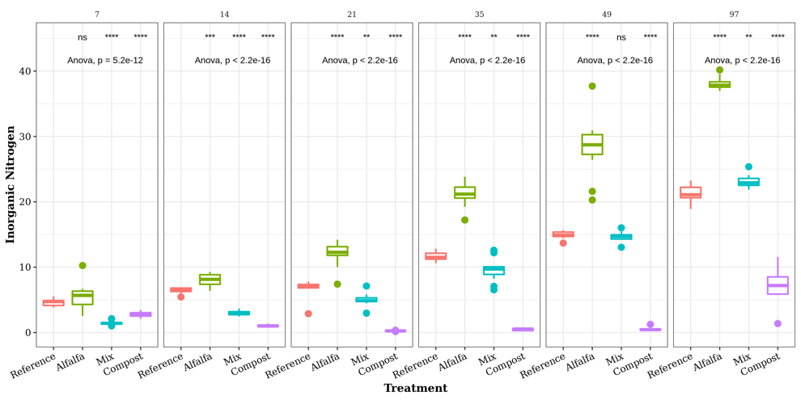

Figure 3 Inorganic N (ppm) measured in mesocosms with no amendment (reference) and various alfalfa, compost, and mixed amendments. Significance indicates….. .

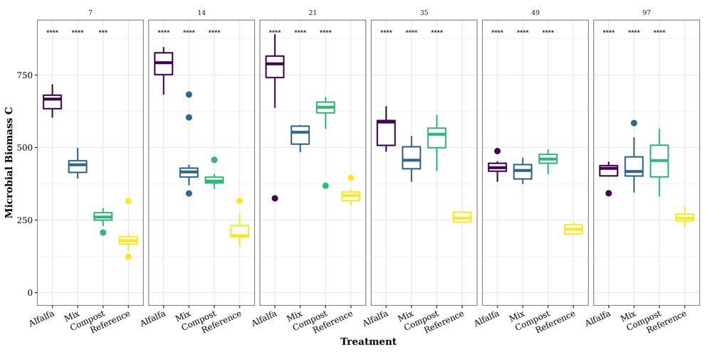

Figure 4 Microbial biomass carbon (units) measured in mesocosms with no amendment (reference) and various alfalfa, compost, and mixed amendments. Significance indicates…..

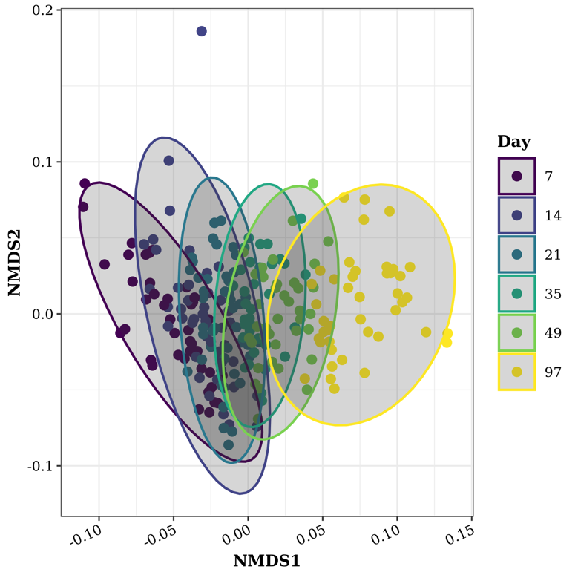

Figure 5 NMDS ordination of the weighted unifrac distance.

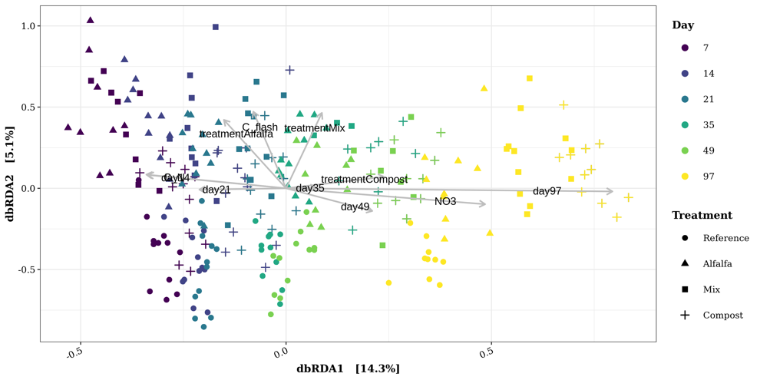

Figure 6 dbRDA ordination with environmental variables fit.

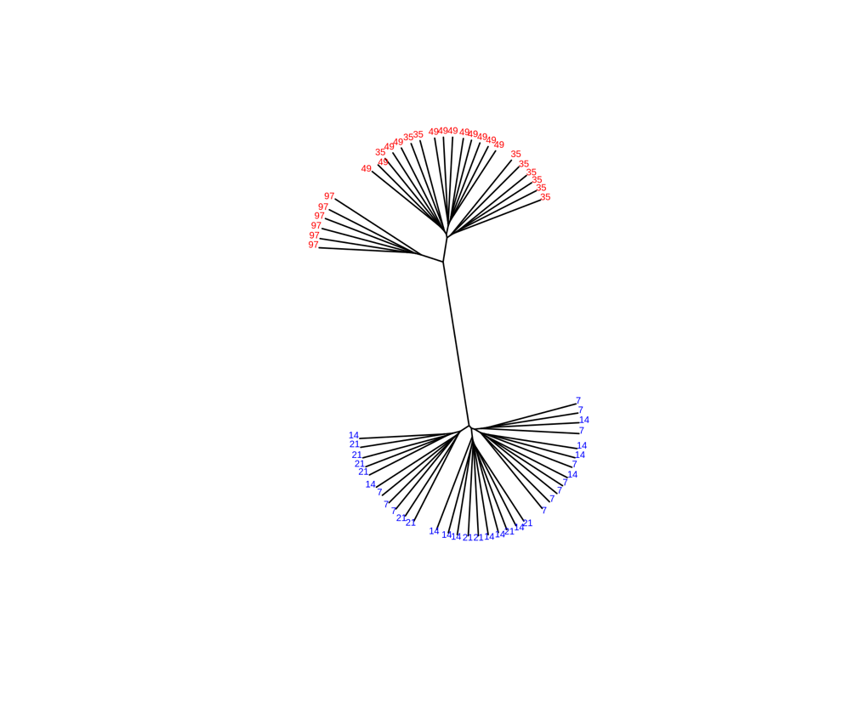

Figure 7

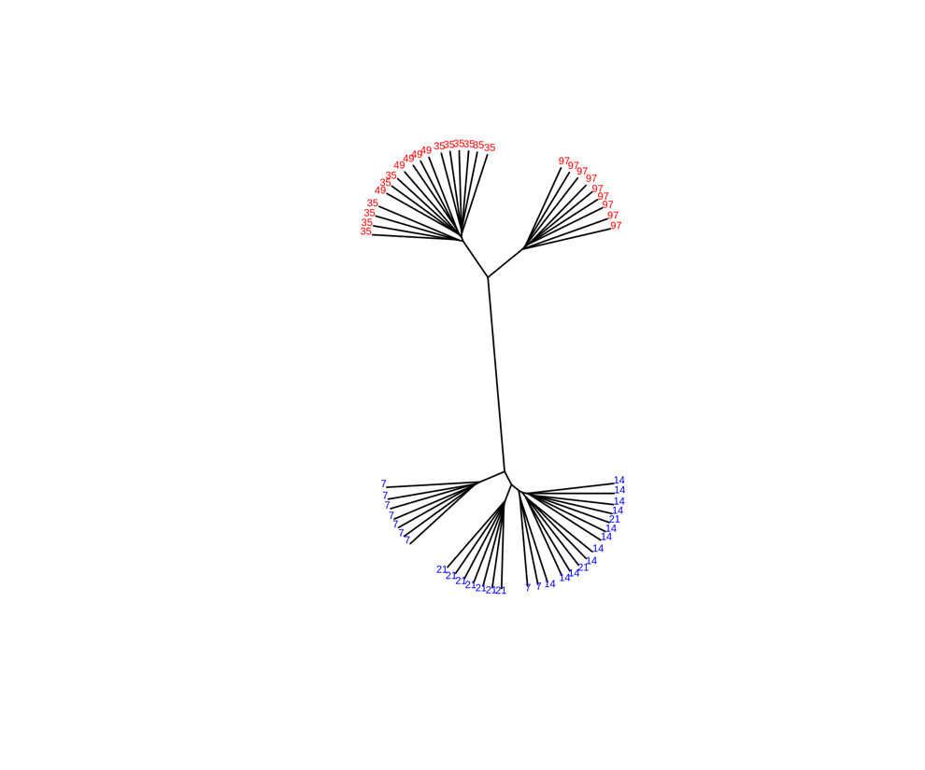

Figure 8

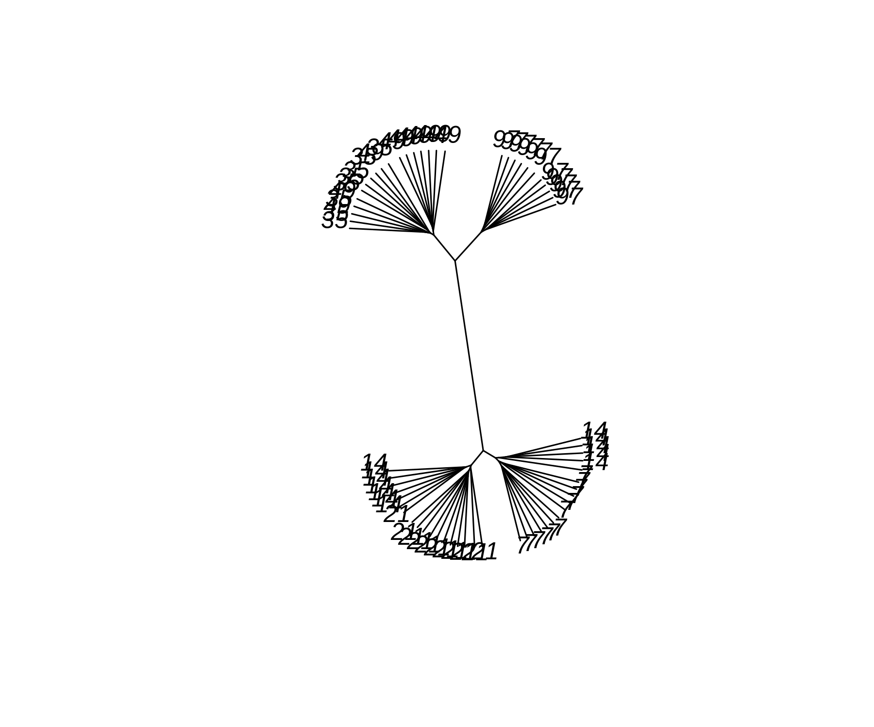

Figure 9

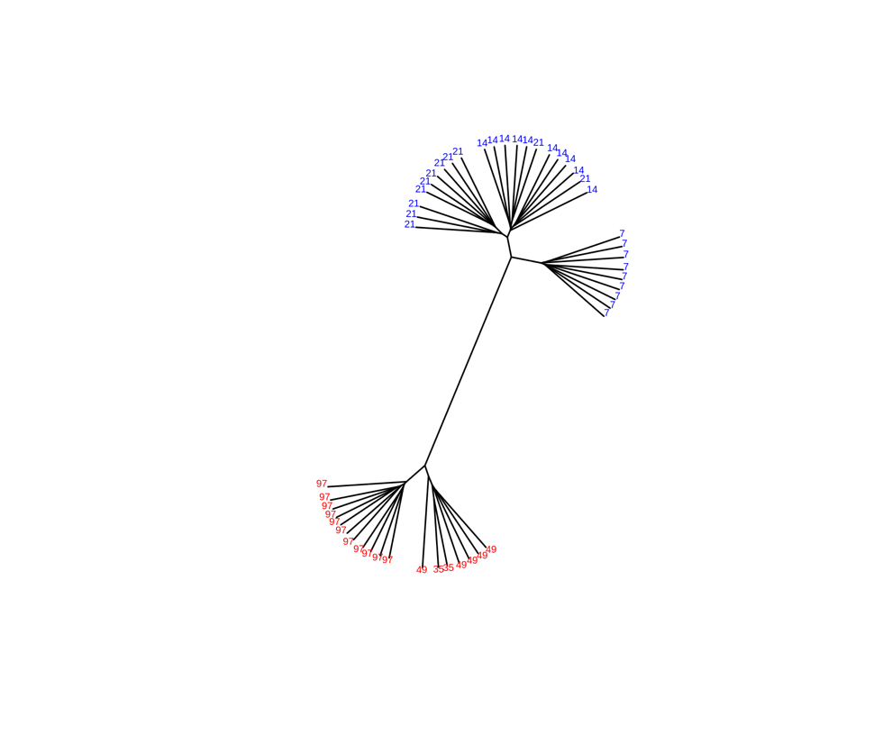

Figure 10

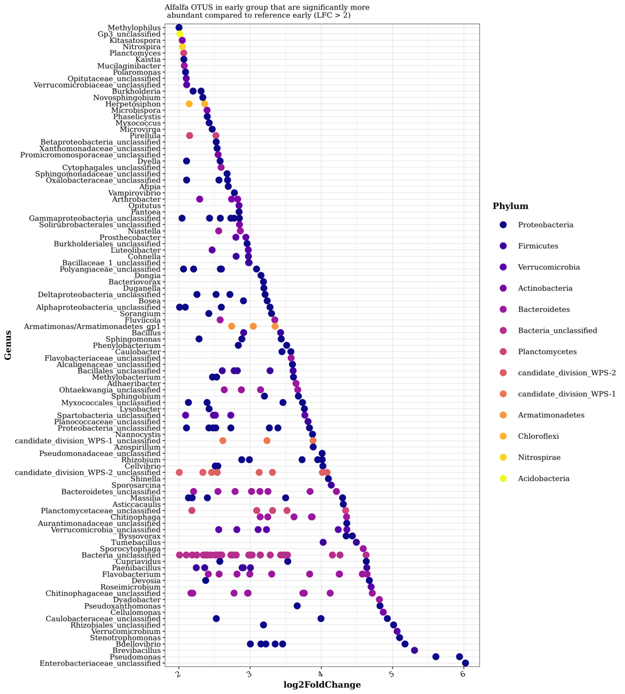

Figure 11

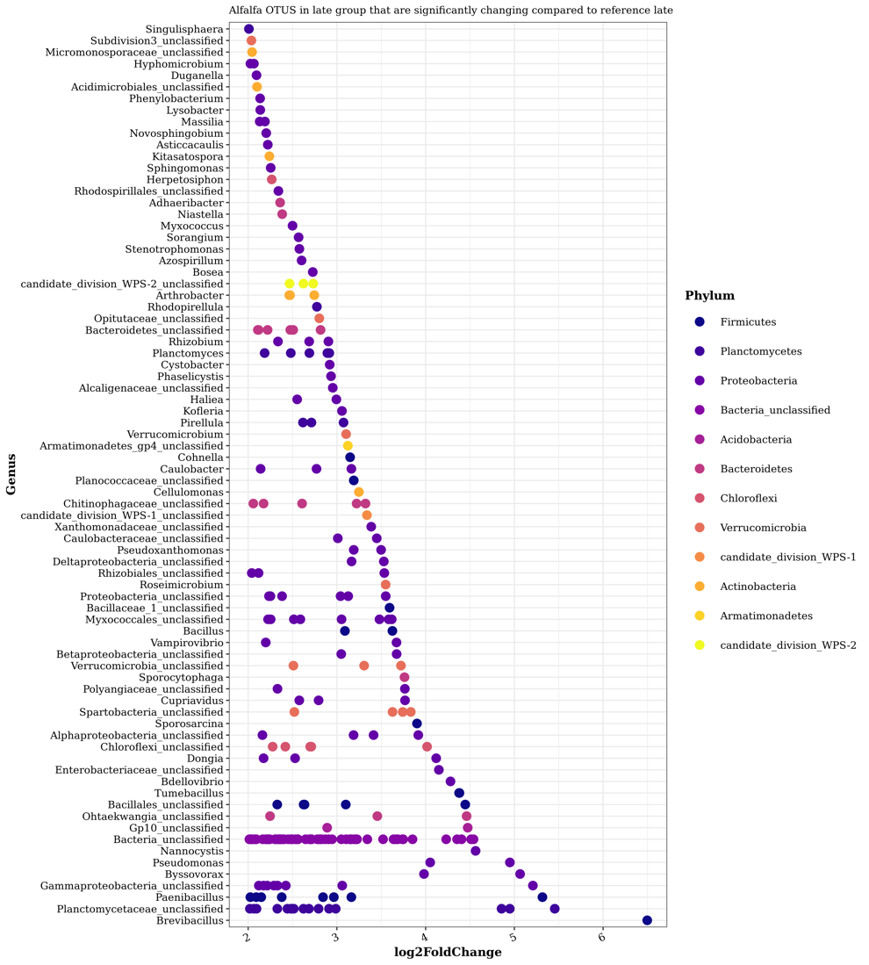

Figure 12

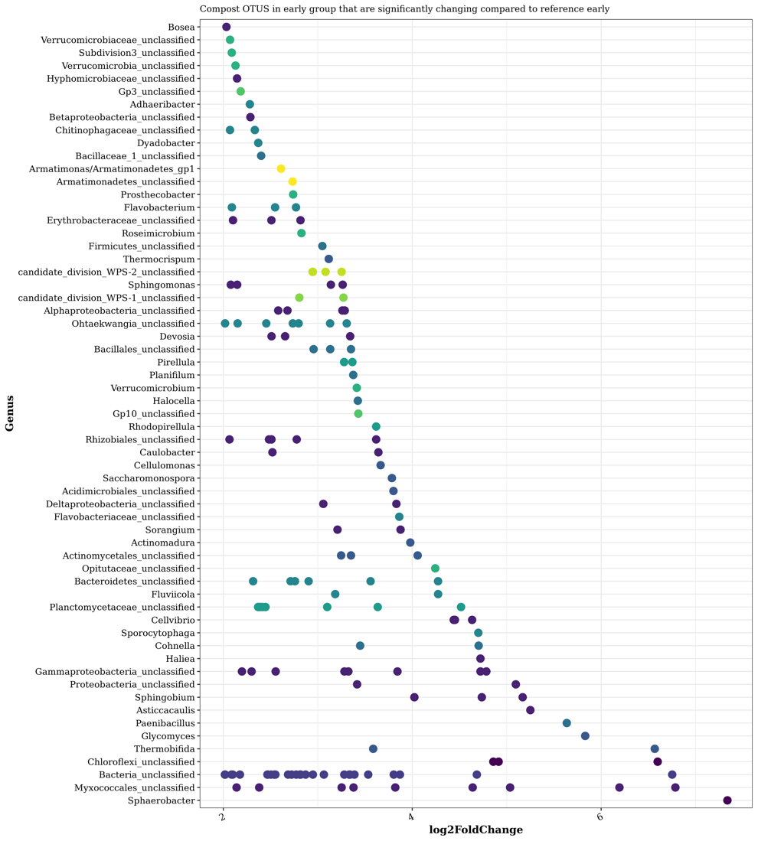

Figure 13

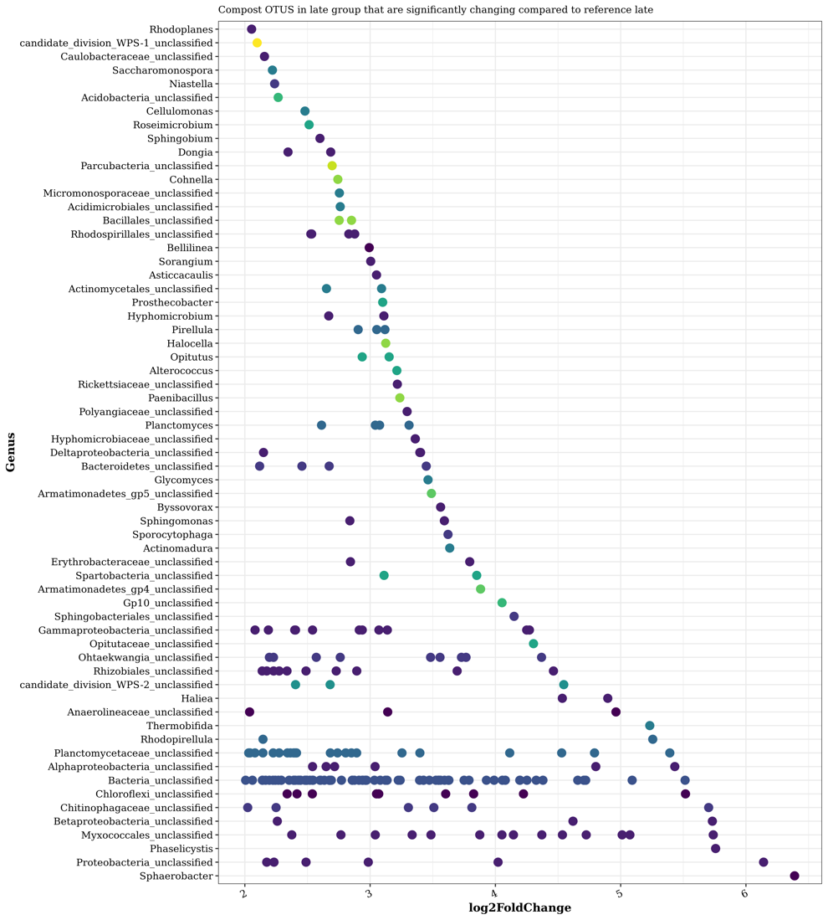

Figure 14

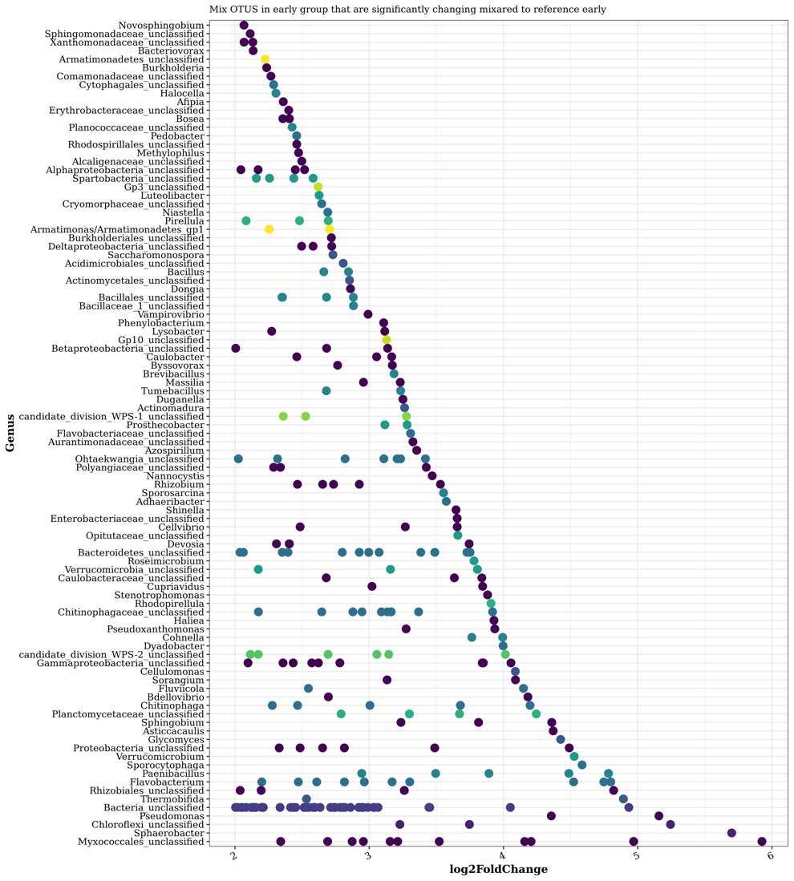

Figure 15

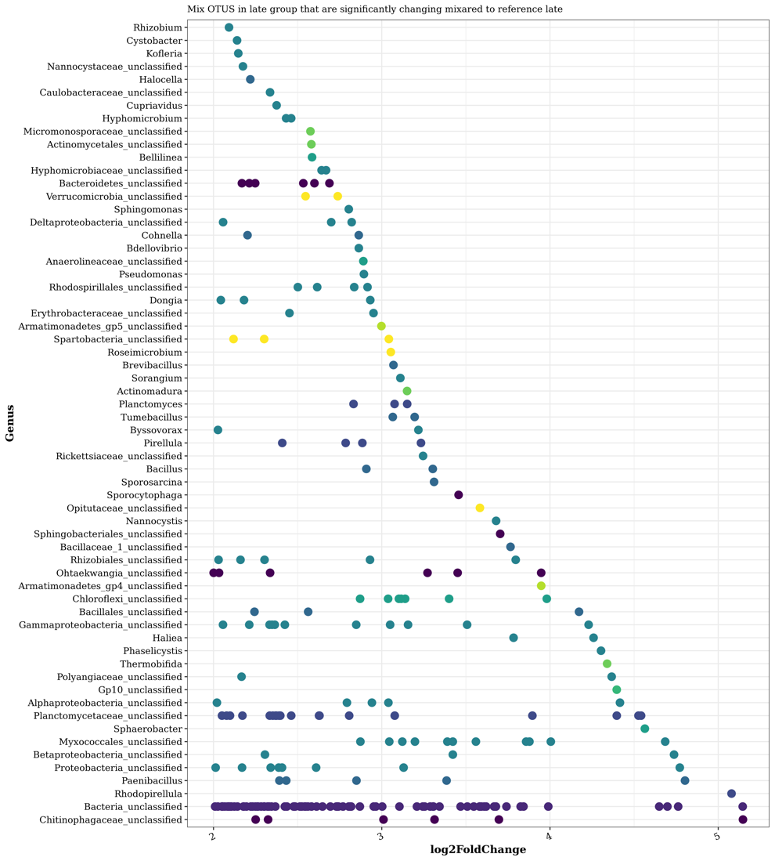

Figure 16

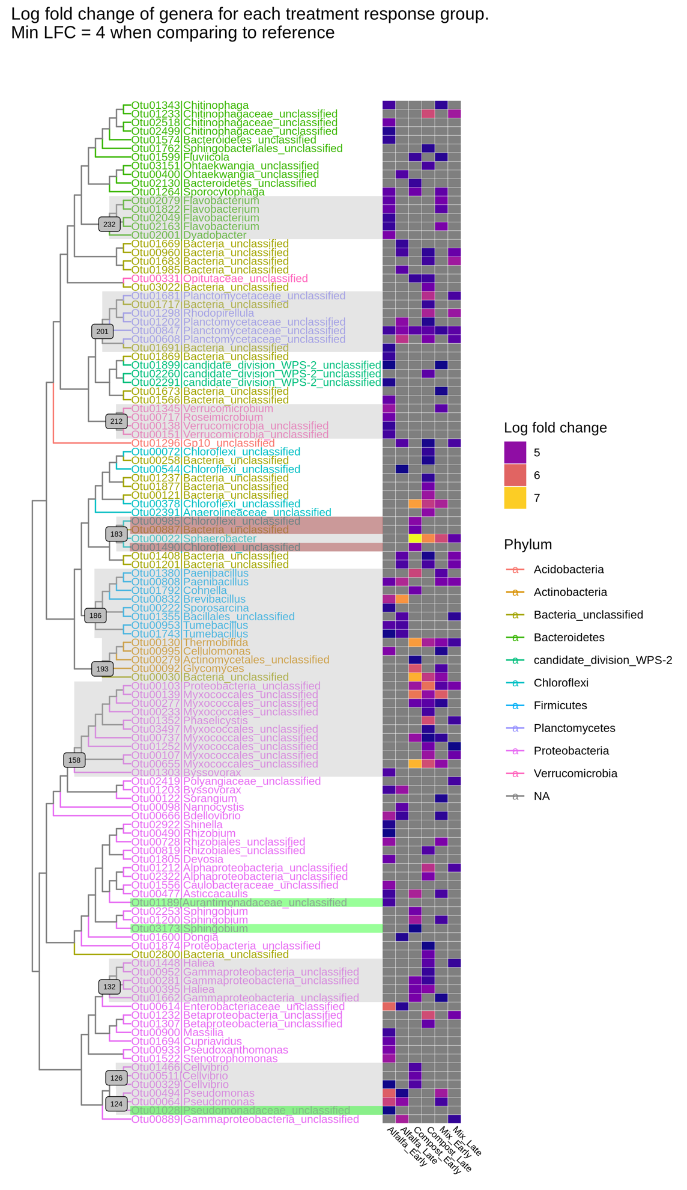

Figure 17

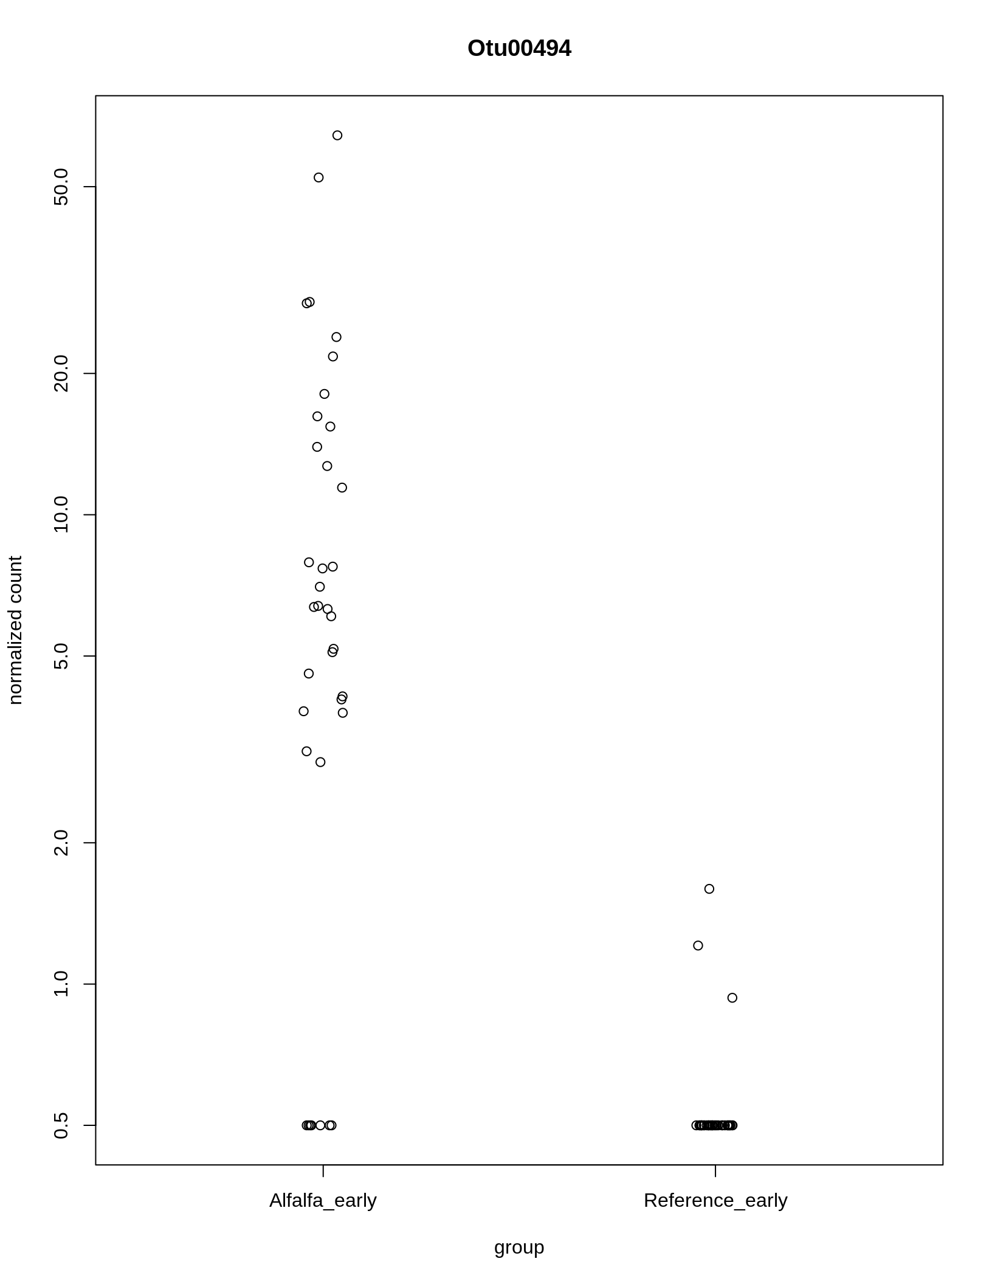

Figure 18

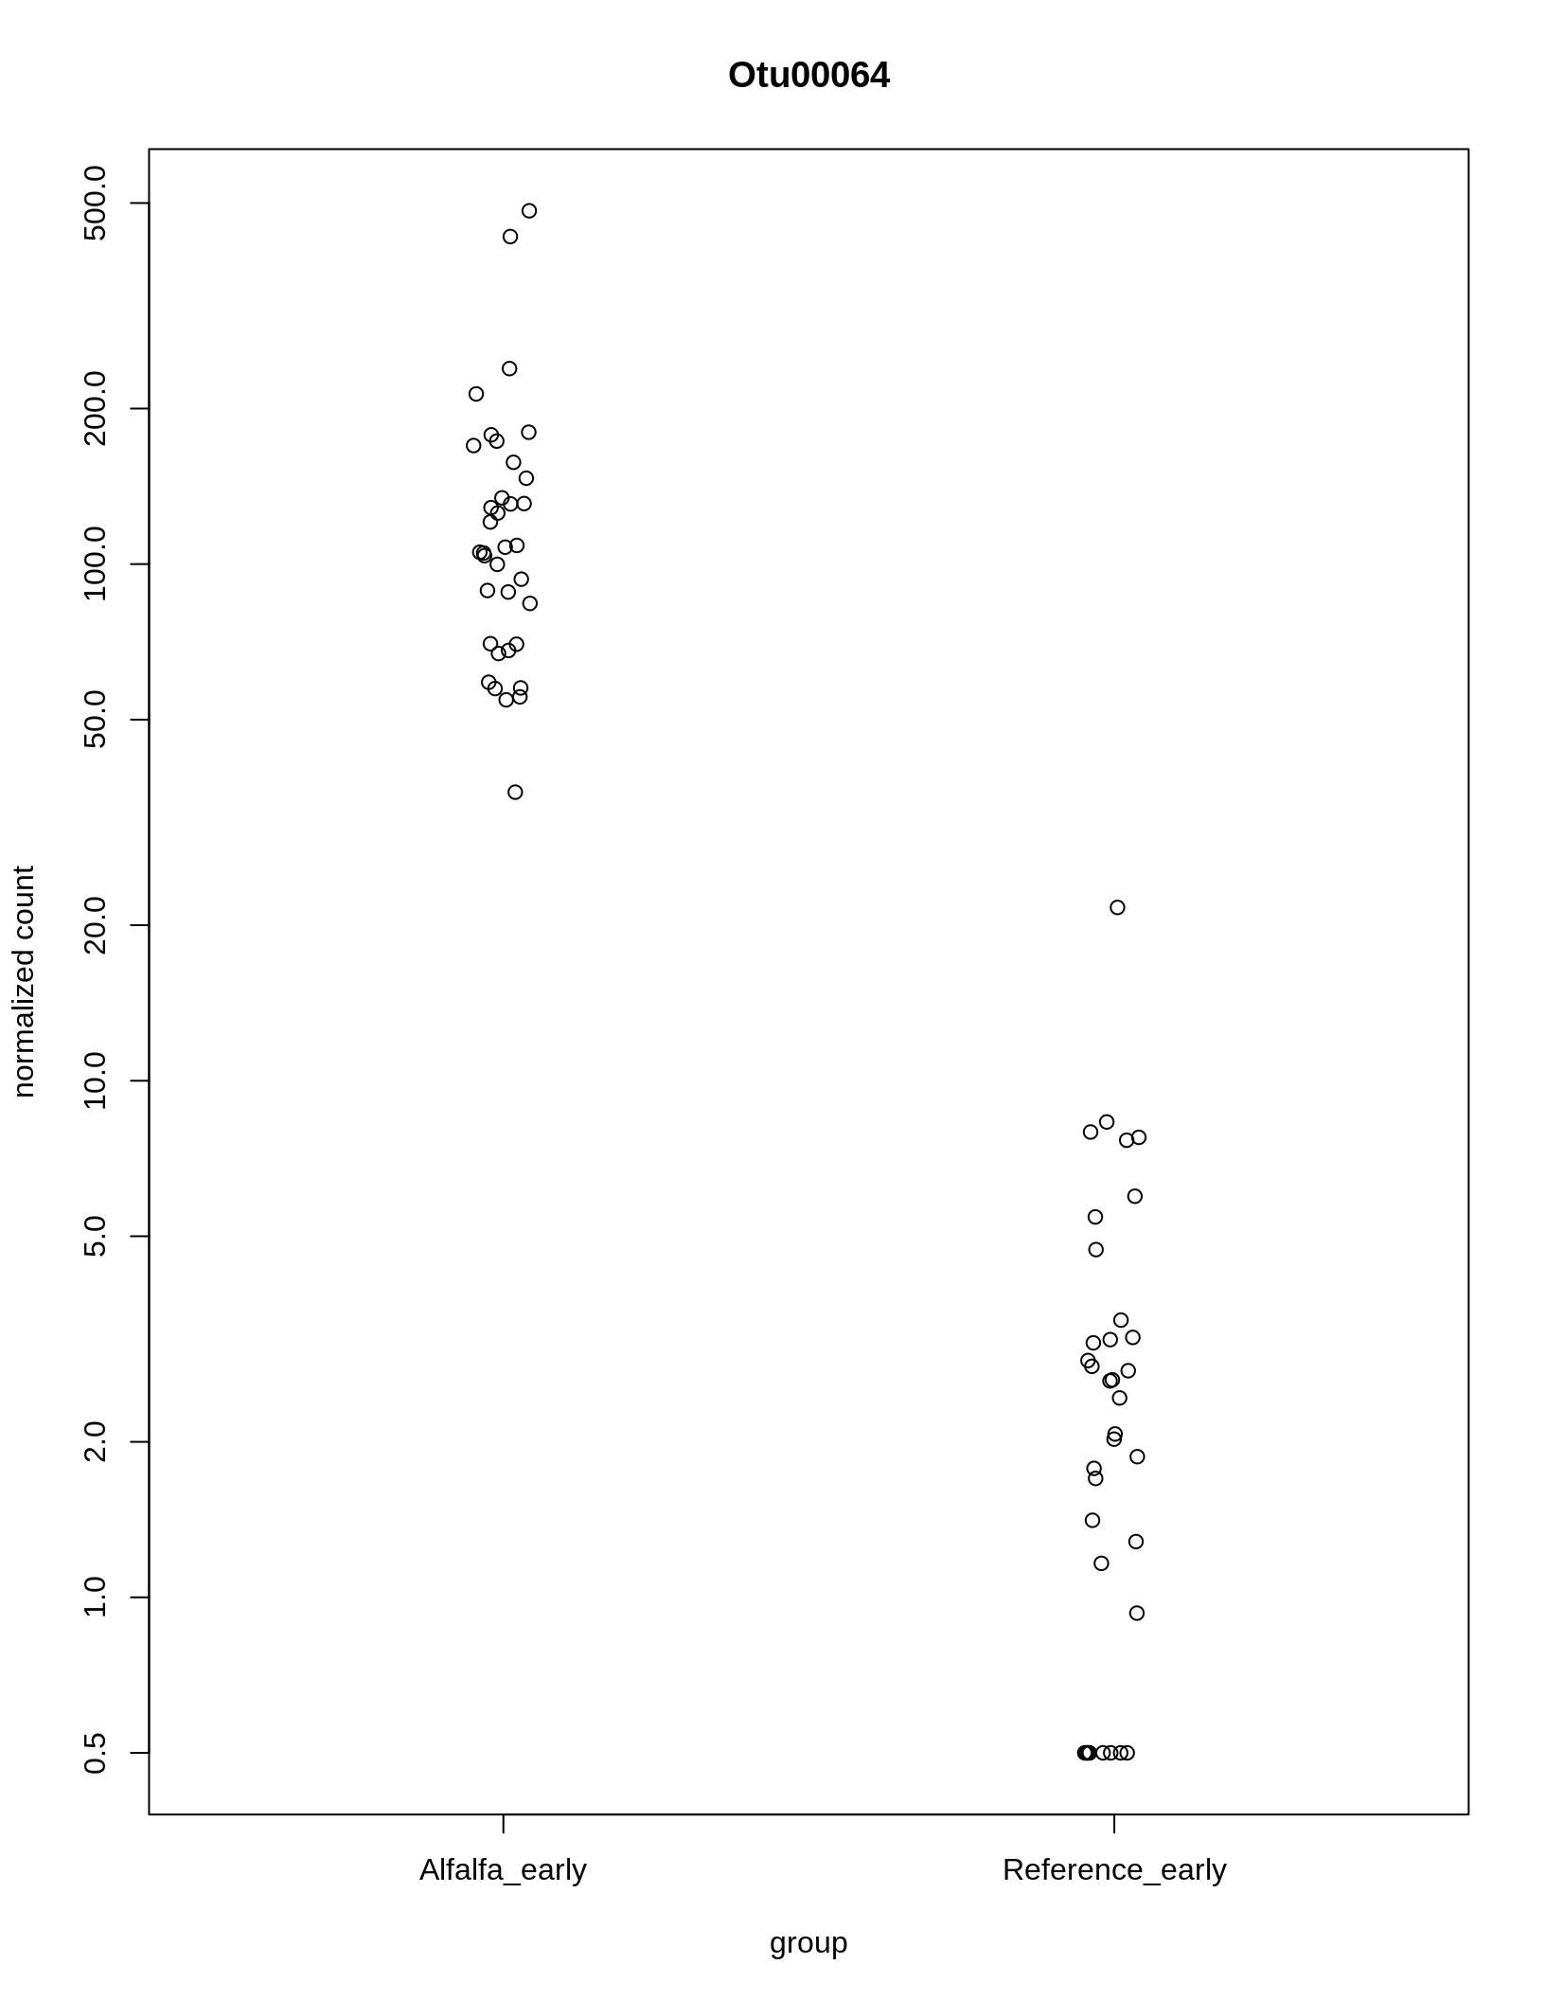

Figure 19

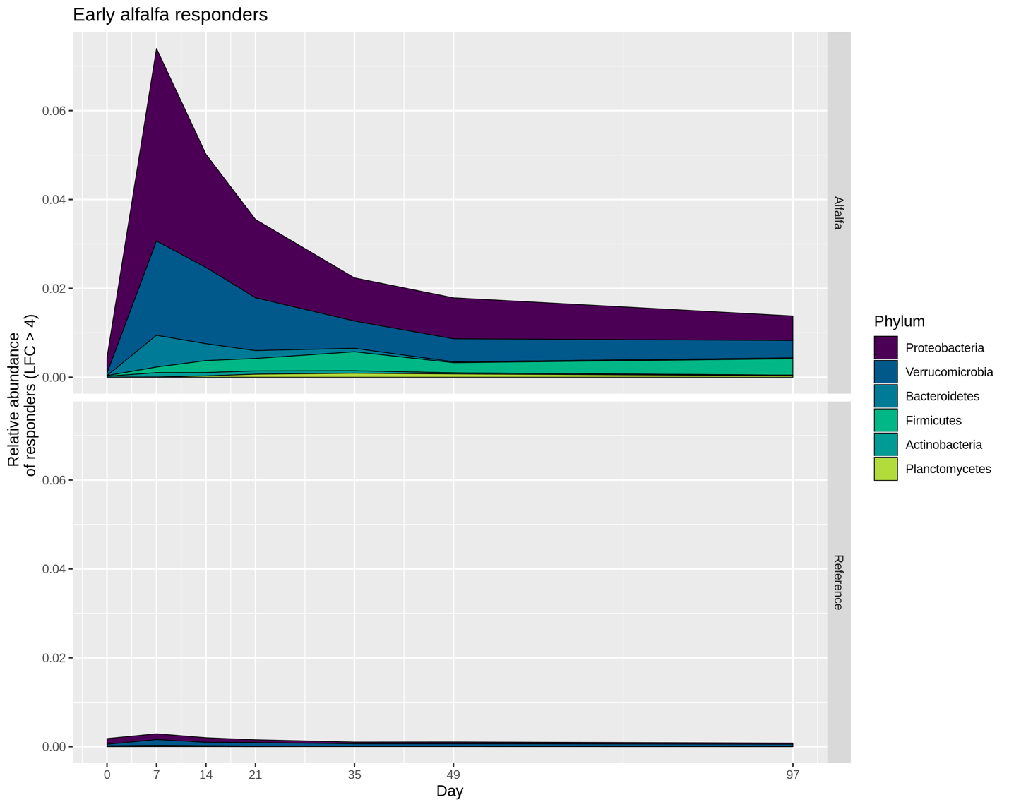

Figure 20

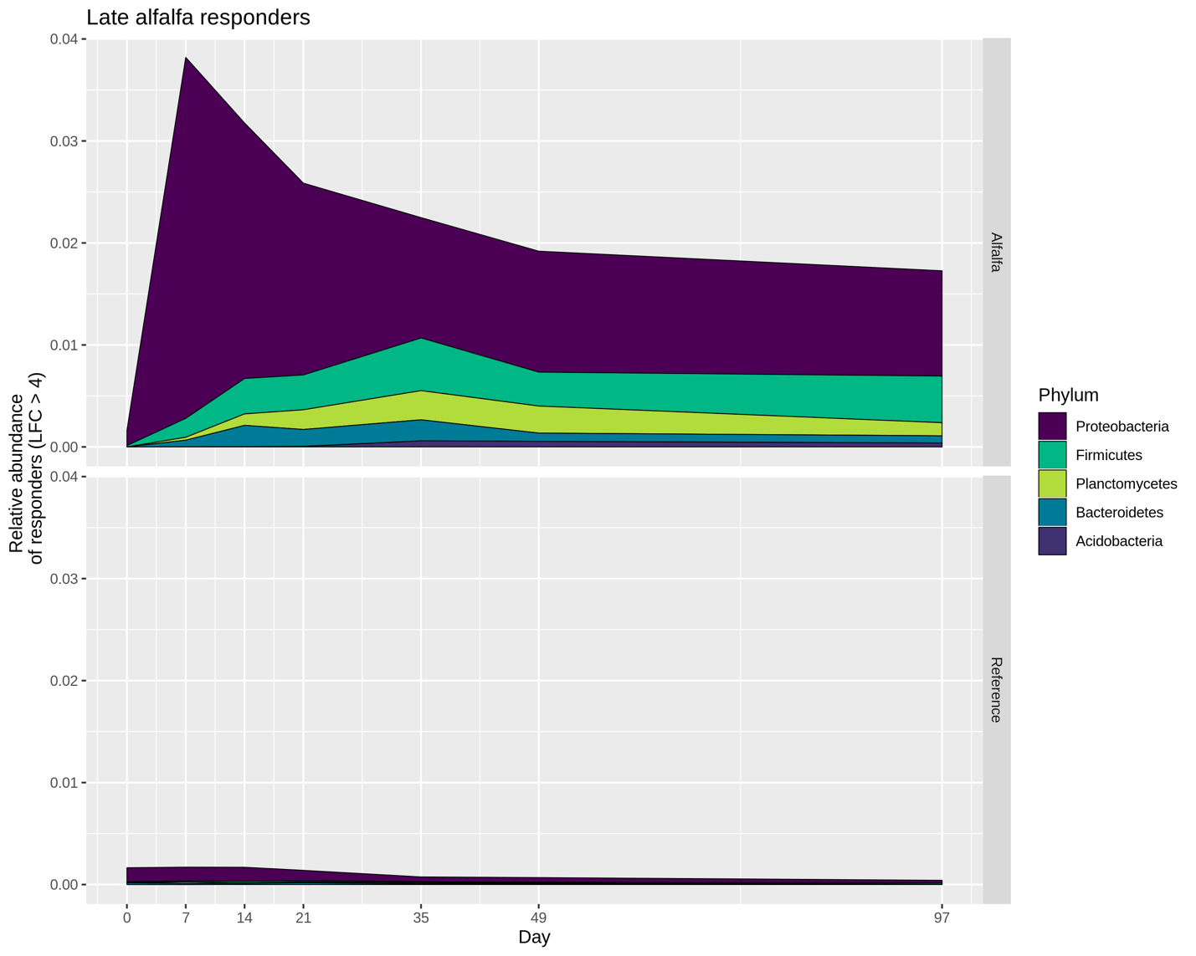

Figure 21

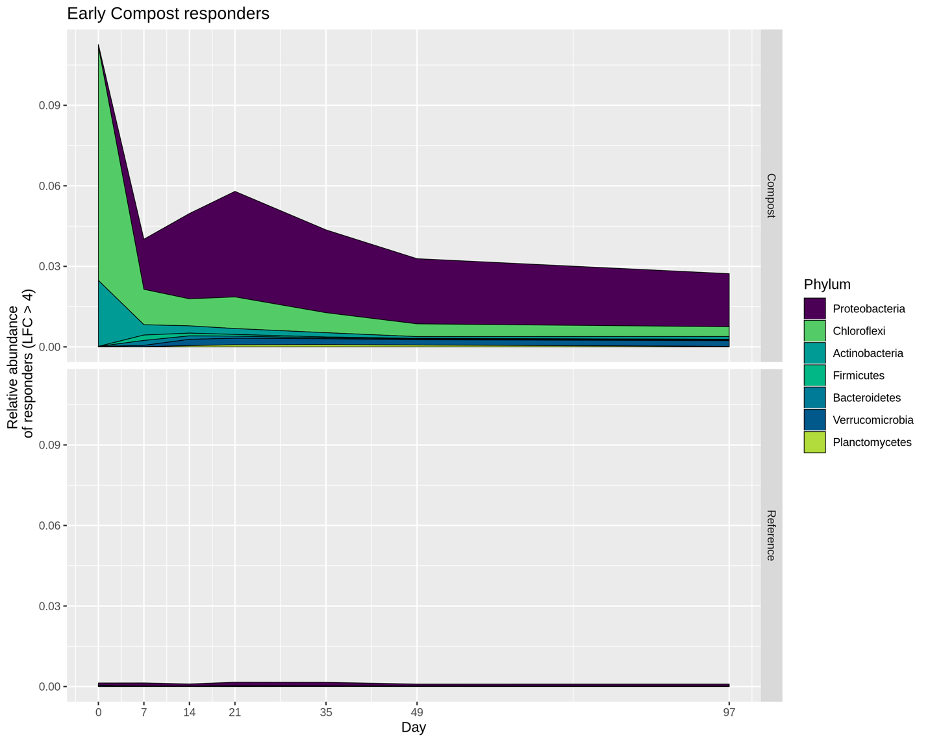

Figure 22

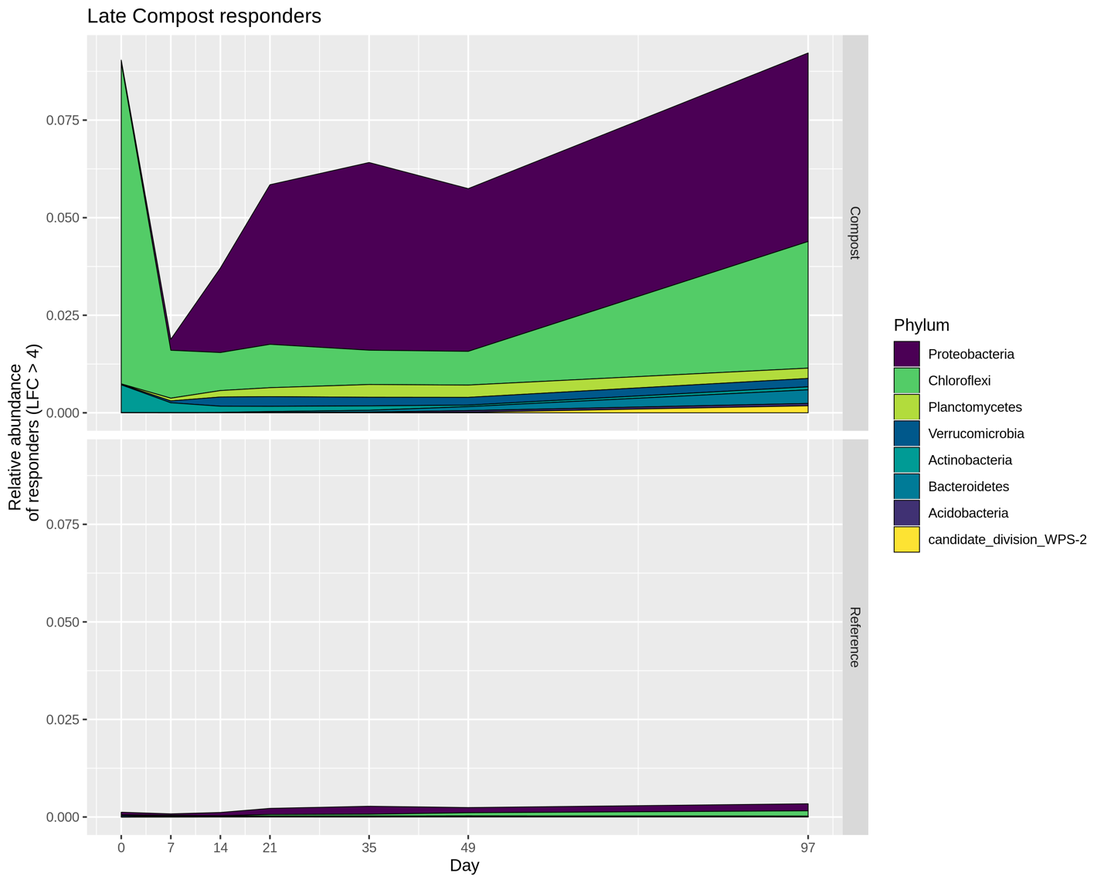

Figure 23

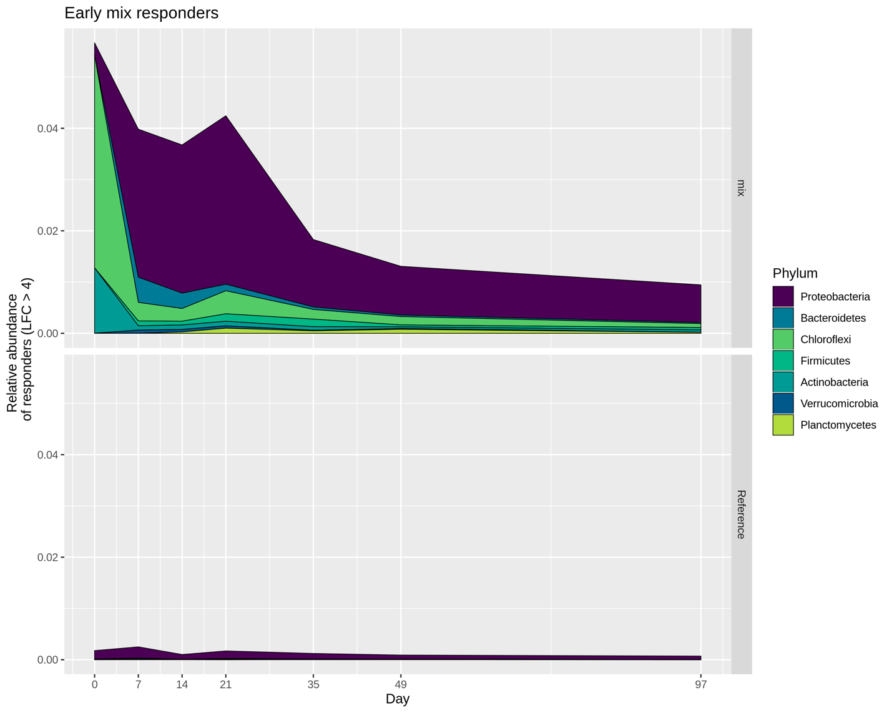

Figure 24

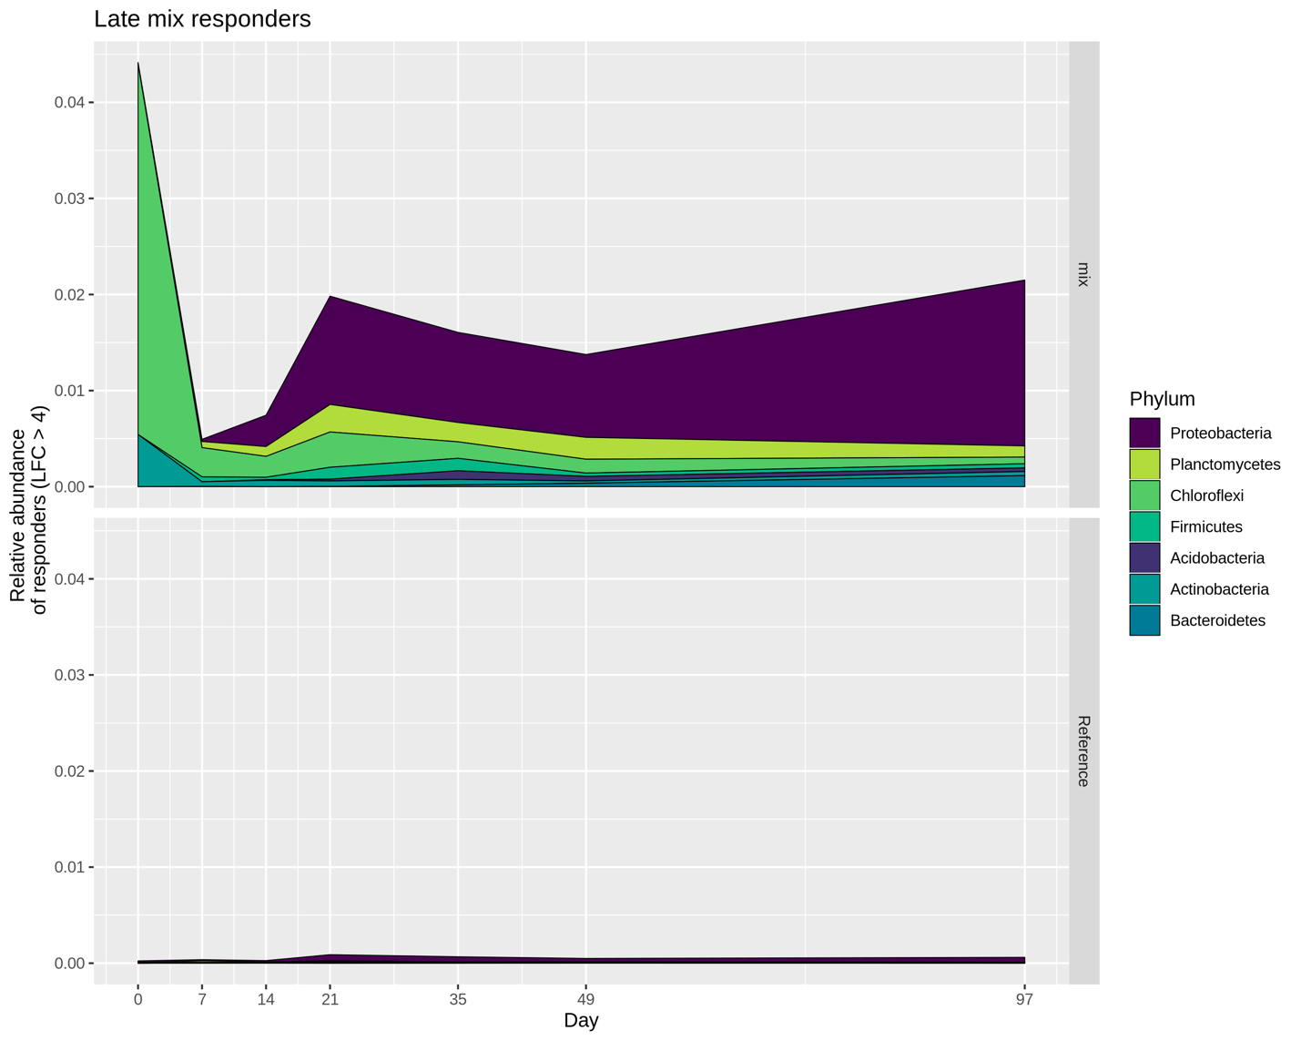

Figure 25

Table 1 Composition of the starting materials.

|  |  |  |  |  |  |  |
| --- | --- | --- | --- | --- | --- | --- |
|  | % C | % N | C:N ratio | NO3 | NH3 | Inorganic N |
| Soil | 2.75 | 0.26 | 10.58 | 1.20 | 2.17 | 3.37 |
| Alfalfa | 41.72 | 2.07 | 20.15 | 5.30 | 20.25 | 25.55 |
| Compost | 33.84 | 1.17 | 28.92 | 1.30 | 12.56 | 13.86 |
| Mixture | 36.24 | 1.44 | 25.16 | 2.54 | 14.89 | 17.43 |

Table 2 Adonis for the incubated samples.

|  |  |  |  |  |  |
| --- | --- | --- | --- | --- | --- |
| formula = distance ~ treatment * day | | | | | |
|  | Df | SumOfSqs | R2 | F | Pr(>F) |
| Treatment | 3 | 0.28 | 0.16 | 26.51 | 0.001 |
| Day | 5 | 0.62 | 0.34 | 34.95 | 0.001 |
| Treatment:Day | 15 | 0.12 | 0.06 | 2.20 | 0.001 |
| Residual | 223 | 0.79 | 0.44 | NA | NA |
| Total | 246 | 1.81 | 1.00 | NA | NA |

Table 3 Amendment-specific OTUs identified in mesocosms.

|  |  |  |  |
| --- | --- | --- | --- |
| Amendment | Total OTUs | Amendment-specific | Proportion of all observed OTUs |
| Alfalfa | 17988 | 67 | 0.46% |
| Compost | 19130 | 307 | 1.14% |
| Mix | 21174 | 386 | 0.74% |

Table 4 Variable selection, variation explained.

|  |  |
| --- | --- |
| Variable | Explains (%) |
| Day | 33.05 |
| Treatment | 15.17 |
| Nitrate | 1.31 |
| C:N | 0.51 |
| TOC | 0.31 |
| Others | 0.21 |
| Unexplained | 49.44 |
| Total | 100 |

Table 5 Alfalfa

|  |  |  |  |  |  |
| --- | --- | --- | --- | --- | --- |
| OTU | Phylum | Class | Genus | Early LFC | Late  LFC |
| Otu00064 | Proteobacteria | Gammaproteobacteria | Pseudomonas | 5.61 | 4.95 |
| Otu00494 | Proteobacteria | Gammaproteobacteria | Pseudomonas | 5.94 | 4.05 |
| Otu00614 | Proteobacteria | Gammaproteobacteria | Enterobacteriaceae_unc | 6.02 | 4.15 |
| Otu00666 | Proteobacteria | Deltaproteobacteria | Bdellovibrio | 5.17 | 4.28 |
| Otu00808 | Firmicutes | Bacilli | Paenibacillus | 4.64 | 5.32 |
| Otu00832 | Firmicutes | Bacilli | Brevibacillus | 5.31 | 6.50 |
| Otu00847 | Planctomycetes | Planctomycetia | Planctomycetaceae_unc | 4.34 | 4.86 |
| Otu00953 | Firmicutes | Bacilli | Tumebacillus | 4.49 | 4.38 |
| Otu01203 | Proteobacteria | Deltaproteobacteria | Byssovorax | 4.35 | 5.06 |
| Otu01743 | Firmicutes | Bacilli | Tumebacillus | 4.02 | 4.38 |

Table 6 Compost

|  |  |  |  |  |  |
| --- | --- | --- | --- | --- | --- |
| OTU | Phylum | Class | Genus | Early LFC | Late  LFC |
| Otu00022 | Chloroflexi | Thermomicrobia | Sphaerobacter | 7.34 | 6.39 |
| Otu00030 | Bacteria_unclassified | Bacteria_unclassified | Bacteria_unclassified | 6.75 | 5.51 |
| Otu00103 | Proteobacteria | Proteobacteria_unclassified | Proteobacteria_unclassified | 5.10 | 6.14 |
| Otu00130 | Actinobacteria | Actinobacteria | Thermobifida | 6.57 | 5.23 |
| Otu00139 | Proteobacteria | Deltaproteobacteria | Myxococcales_unclassified | 6.19 | 5.01 |
| Otu00277 | Proteobacteria | Deltaproteobacteria | Myxococcales_unclassified | 4.64 | 4.53 |
| Otu00281 | Proteobacteria | Gammaproteobacteria | Gammaproteobacteria_unc | 4.72 | 4.27 |
| Otu00331 | Verrucomicrobia | Opitutae | Opitutaceae_unclassified | 4.24 | 4.30 |
| Otu00378 | Chloroflexi | Chloroflexi_unclassified | Chloroflexi_unclassified | 6.60 | 5.52 |
| Otu00395 | Proteobacteria | Gammaproteobacteria | Haliea | 4.72 | 4.90 |
| Otu00655 | Proteobacteria | Deltaproteobacteria | Myxococcales_unclassified | 6.79 | 5.74 |
| Otu00737 | Proteobacteria | Deltaproteobacteria | Myxococcales_unclassified | 5.04 | 4.05 |
| Otu00847 | Planctomycetes | Planctomycetia | Planctomycetaceae_unc | 4.52 | 4.53 |

Table 7 Mix

|  |  |  |  |  |  |
| --- | --- | --- | --- | --- | --- |
| OTU | Phylum | Class | Genus | Early LFC | Late LFC |
| Otu00022 | Chloroflexi | Thermomicrobia | Sphaerobacter | 5.70 | 4.56 |
| Otu00103 | Proteobacteria | Proteobacteria_unclassified | Proteobacteria_unclassified | 4.49 | 4.77 |
| Otu00130 | Actinobacteria | Actinobacteria | Thermobifida | 4.89 | 4.34 |
| Otu00808 | Firmicutes | Bacilli | Paenibacillus | 4.78 | 4.80 |
| Otu00847 | Planctomycetes | Planctomycetia | Planctomycetaceae_unclassified | 4.24 | 4.54 |